Computer Systems and Internet Technologies - COMP1589

HTML, CSS & JS
Lab

SUMMARY
In this lab you will test your HTML and CSS knowledge, as well as be introduced to JavaScript. For this lab you will ideally be using Visual Studio Code and Google Chrome, within Google Chrome we will be using the developer tools - if you’re unfamiliar with these please review lab 1 or ask for help.

OBJECTIVES
- To be able to write valid HTML code and identify invalid code
- To be able to write valid CSS code and identify invalid code
- To begin to understand the potential of JavaScript and how we can debug this within the console

HTML & CSS TASK
This week I want you to challenge yourself and utilise the tool of professional developers, by this I of course mean Google. Your challenge is to take the code provided below, and fix/complete this, to match our design - i’ve helped you by breaking this down into specific tasks below.
No one would, reasonably, expect you to memorise all of the different HTML tags and CSS properties you can use. However you will be expected to have the ability to source the best approach to a problem using a variety of tags and properties, as well as have the skills to understand code and how it should look (i.e. does it look correct in the browser, matching what the code describes).
The output of your code should look like this:
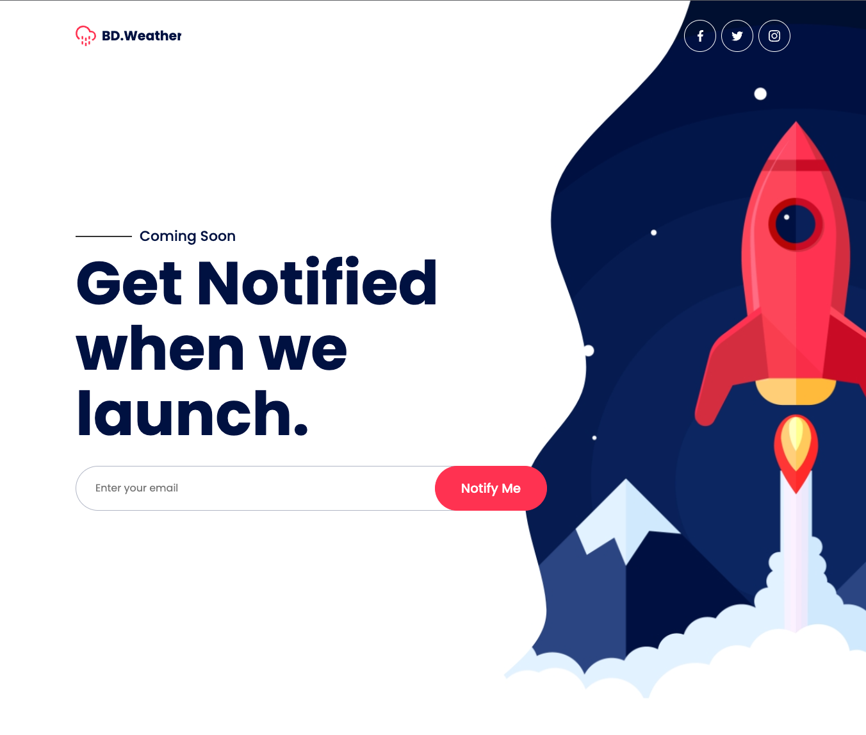

The approach you’re taking here could be considered a very basic version of Test Driven Design (TDD). A way of development in which you first write tests to describe your product and then build solutions to these tests.
- The page should appear to have styling (hint: check the dev tools console for any errors)
- The title showing in the browser tab should say “Welcome to Rocket Inc.”
- The header background should not be red
- The social media icons should open in a new tab
- The facebook icon should navigate to Facebook
- The button should have white text with our brand red(#FF3251) background
- The button should be rounded by the same amount as the input field
- The line before “coming soon” should be vertically centred with the text
- The rocket image should be visible
- The line height of the H1 should be 1.1
- The form should be 30px from the title
- The HTML code should not have any errors when being validated at https://validator.w3.org/#validate_by_input (warnings are fine)
- CHALLENGE: the moon on the rocket image should be visible

JAVASCRIPT TASK
If you managed to blitz through the HTML/CSS task, or you want to fully complete this lab, then let’s move onto JavaScript.
Using the fixed files from our HTML/CSS task above we’re going to add a countdown that refreshes at the click of a button.

Step 1
Let’s very quickly add a UI section for our output to display, under our H1 tag (above our form) add in the following P tag.
<p style="font-size: 30px; line-height: 2;">
<span id="launch_counter">00:00:00</span>
<button style="background: none; border: none;">
<img style="width: 30px; height: auto; display: block;" src="https://cdn0.iconfinder.com/data/icons/glyphpack/41/refresh-512.png">
</button>
</p>
It should look something like this:
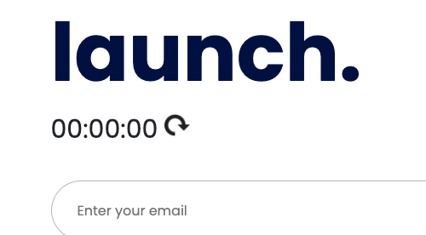

Step 2
Towards the end of your code, just before the closing body tag (</body>) add the following:
<script>
// Set the date we're counting down to, we assign to a constant as this shouldn't be changed in our code.
// We are using the date object (https://www.w3schools.com/jsref/jsref_obj_date.asp) with a date string, a special string format that JS understands
// We are then converting this to a unix timestamp, although in milliseconds not seconds
const launchDate = new Date('June 5, 2022 11:00:00').getTime()
const calculateDifference = () => {
// Get the time right now
const now = new Date().getTime()
// Work out the difference between the two timestamps
return launchDate - now;
}
const updateCounter = () => {
const timeDifference = calculateDifference()
// Calculate the time in days, hours, minutes, seconds
const days = Math.floor(timeDifference / (1000 * 60 * 60 * 24))
const hours = Math.floor((timeDifference % (1000 * 60 * 60 * 24)) / (1000 * 60 * 60))
const minutes = Math.floor((timeDifference % (1000 * 60 * 60)) / (1000 * 60))
const seconds = Math.floor((timeDifference % (1000 * 60)) / 1000)
// Find the element we want to interact with by it's ID attribute
const outputElement = document.getElementById('launch_counter')
// Update the HTML of that element
outputElement.innerHTML = days + "d " + hours + "h " + minutes + "m " + seconds + "s "
}
</script>

Step 3
The code above, on its own, won’t do anything however if you open your devtools and click “Console”. You will see you have an interface, a bit like a command line, where you can enter code.
This is your JavaScript console, it lets you test, debug and run JavaScript code. Let’s give it a go, write `launchDate` and press enter - you should need a number being printed to screen. This is the value of our variable “launchDate” in our code.
Try it with “calculateDifference()” as well, you should see the return of that function.
Now try it with “timeDifference”. This will throw an error, because even though the variable exists in our code, it only exists within our “updateCounter” function and not within the global scope.
Finally try entering “updateCounter()”, you should see the counter on screen update to display the time until the launch date.
Step 4
So we now have our code to update our counter but we can’t expect our users to open devtools, navigate to the console and run the function themselves.
Let’s provide them with a way to interact with the site using JavaScript, we do this through events. There are two main ways to work with events, one is in HTML and the other is purely in JavaScript.
Let’s look at HTML this week, the syntax for events is fairly simple - if we want to trigger some code run when someone's mouse is moving over an element we would add an attribute to our HTML element for the event “onmouseover”.
Most events are prepended with “on”, events such as onclick, onload, onchange, etc. You can view a big list here https://www.w3schools.com/jsref/dom_obj_event.asp, for all of them you just prepend “on”.
Within your attribute you’d then put the JavaScript you want to run, try updating our button to this and then click the button, if it worked you’ll know.
<button style="background: none; border: none;" onclick="alert('You clicked me')">
Step 5
Time for a bit of independent coding:
- Update the button with the refresh icon so that when it’s clicked the counter updates, hint: we need to call updateCounter
- When you refresh the page the time clears, and when you first load it’s just a lot of zeros - try to work out what additional line of code we need to fix this - hint: it’s a function call
- Try changing the year of the launch date to last year, notice that the numbers are now all minuses - can you add the extra code to make it say “Launched” if the date has passed? (hint: using “console.log” can be very helpful here, or checking the output of calculateDifference in console)
- If you want to challenge yourself, see if you can make the timer update automatically so that the countdown appears live when you’re on the site (hint: you need to use an interval)

RESOURCES
If you get stuck on any of the challenges above be sure to check out the following resources:
HTML elements reference
HTML Cheatsheet | CodeWithHarry
CSS: Cascading Style Sheets | MDN
CSS Cheat Sheet
CSS features reference - Chrome Developers
Expressions and operators - JavaScript | MDN
JavaScript (JS) Cheat Sheet Online
Chrome DevTools

